Министерство науки и высшего образования Российской Федерации
Муромский институт (филиал)
Федерального государственного бюджетного образовательного учреждения высшего образования
«Владимирский государственный университет
имени Александра Григорьевича и Николая Григорьевича Столетовых»

Факультет ИТР
Кафедра ПИн

ЛАБОРАТОРНАЯ
РАБОТА №3

По Компьютерной графике

Руководитель
Привезенцев Д.Г.
(фамилия, инициалы)

(подпись) (дата)

Студент ПИн - 121
(группа)
Ермилов М.В.
(фамилия, инициалы)

(подпись) (дата)

Муром 2023
Лабораторная работа №3

Тема: Создание игры Tower Defense

Скрипты проекта
TowerPlacer.cs
using System.Collections;
using System.Collections.Generic;
using UnityEngine;
using UnityEngine.Tilemaps;

public class Tower
{
public Vector3Int Vector { get; set; }
public Tile Tile { get; set; }
public int Level { get; set; }
public float CurrentAngle { get; set; }
public float TimeTill { get; set; }
public Vector3 WorldPosition { get; set; }
public float TimeToReload { get; set; }
public float ReloadTime { get; set; }
public GameObject Bullet { get; set; }
public int Damage { get; set; }

}

public class TowerPlacer : MonoBehaviour
{
public Tilemap mapPlatforms;
public Tilemap mapTowers;
public Tile Tower;
public Tile TileBase;
private Camera mainCamera;
public GameObject Bullet;
List<Tower> towers;
void Start()
{
mainCamera = Camera.main;
towers = new List<Tower>();
}
float timeTill = 0.0f;
void Update()
{
if (Input.GetMouseButtonDown(0))
{
Vector3 click = mainCamera.ScreenToWorldPoint(Input.mousePosition);
Vector3Int cellClick = mapPlatforms.WorldToCell(click);
if (mapPlatforms.GetTile(cellClick) == TileBase)
{
mapTowers.SetTile(cellClick, Tower);

towers.Add(new Tower)
{
Vector = cellClick,
Tile = Tower,
Level = 1,
WorldPosition = click,
TimeTill = 0.0f,
Damage = 25,
Bullet = Bullet,
ReloadTime = 1f
});
}
}
if (timeTill > 2)
{
foreach (var tower in towers)
{
tower.CurrentAngle += 45;
Matrix4x4 matrix = Matrix4x4.TRS(Vector3.zero, Quaternion.Euler(0f, 0f, tower.CurrentAngle), Vector3.one);
mapTowers.SetTransformMatrix(tower.Vector, matrix);
}
timeTill = 0.0f;
}
timeTill += Time.deltaTime;
foreach (var tower in towers)
{
if (tower.TimeToReload == 0)
{
Collider2D[] colliders = Physics2D.OverlapCircleAll(new Vector2(tower.WorldPosition.x, tower.WorldPosition.y), 2);
Debug.Log(colliders.Length);
foreach (Collider2D collider in colliders)
{
Shoot(collider, tower);
tower.TimeToReload = tower.ReloadTime;
break;
}
}
else
tower.TimeToReload = Mathf.Max(0, tower.TimeToReload - Time.deltaTime);
}
}
void Shoot(Collider2D target, Tower tower)
{
Vector3 startPosition = tower.WorldPosition;
Vector3 targetPosition = target.transform.position;
startPosition.z = tower.Bullet.transform.position.z;
targetPosition.z = tower.Bullet.transform.position.z;
GameObject newBullet = (GameObject)Instantiate(tower.Bullet);
newBullet.transform.position = startPosition;
BulletBehavior bulletComp = newBullet.GetComponent<BulletBehavior>();
bulletComp.target = target.gameObject;
bulletComp.startPosition = startPosition;
bulletComp.targetPosition = targetPosition;
bulletComp.damage = tower.Damage;
}
}

SpawnEnemy.cs
using System.Collections;
using System.Collections.Generic;
using UnityEngine;
public class SpawnEnemy : MonoBehaviour
{
[System.Serializable]
public class Wave
{
public GameObject enemyPrefab;
public float spawnInterval = 2;
public int maxEnemies = 20;
}
public GameObject[] waypoints;
private int wave;
public Wave[] waves;
public int timeBetweenWaves = 5;
private float lastSpawnTime;
private int enemiesSpawned = 0;
private void Start()
{
lastSpawnTime = Time.time;
wave = 0;
}
void Update()
{
if (wave < waves.Length)
{

float timeInterval = Time.time - lastSpawnTime;
float spawnInterval = waves[wave].spawnInterval;
if (((enemiesSpawned == 0 && timeInterval > timeBetweenWaves) ||
timeInterval > spawnInterval) &&
enemiesSpawned < waves[wave].maxEnemies)
{
lastSpawnTime = Time.time;
GameObject newEnemy = Instantiate(waves[wave].enemyPrefab) as GameObject;
newEnemy.GetComponent<MoveEnemy>().waypoints = waypoints;
enemiesSpawned++;
}
if (enemiesSpawned == waves[wave].maxEnemies &&
GameObject.FindGameObjectWithTag("Enemy") == null)
{
wave++;
enemiesSpawned = 0;
lastSpawnTime = Time.time;
}
}
}
}

MoveEnemy.cs
using System.Collections;
using System.Collections.Generic;
using UnityEngine;
public class MoveEnemy : MonoBehaviour
{
[HideInInspector]
public GameObject[] waypoints;
private int currentWaypoint = 0;
private float lastWaypointSwitchTime;
public float speed = 1.0f;
public Transform SpriteTransform;
void Start()
{
lastWaypointSwitchTime = Time.time;
}
void Update()
{
Vector3 startPosition = waypoints[currentWaypoint].transform.position;
Vector3 endPosition = waypoints[currentWaypoint + 1].transform.position;
float pathLength = Vector3.Distance(startPosition, endPosition);
float totalTimeForPath = pathLength / speed;
float currentTimeOnPath = Time.time - lastWaypointSwitchTime;
gameObject.transform.position = Vector2.Lerp(startPosition, endPosition,
currentTimeOnPath / totalTimeForPath);
if (gameObject.transform.position.Equals(endPosition))
{
if (currentWaypoint < waypoints.Length - 2)
{
currentWaypoint++;
lastWaypointSwitchTime = Time.time;
RotateIntoMoveDirection();
}
else
{
Destroy(gameObject);
}
}
}
void RotateIntoMoveDirection()
{
Vector3 newStartPosition = waypoints[currentWaypoint].transform.position;
Vector3 newEndPosition = waypoints[currentWaypoint + 1].transform.position;
Vector3 newDirection = (newEndPosition - newStartPosition);
float x = newDirection.x;
float y = newDirection.y;
float rotationAngle = Mathf.Atan2(y, x) * 180 / Mathf.PI;
SpriteTransform.transform.rotation = Quaternion.AngleAxis(rotationAngle,
Vector3.forward);
}
}

HealthBar.cs
using System.Collections;
using System.Collections.Generic;
using UnityEngine;
public class HealthBar : MonoBehaviour
{
public float maxHealth = 100;
public float currentHealth = 100;
private float originalScale;
public void Start()
{
originalScale = gameObject.transform.localScale.x;
currentHealth = 100;
}
private void Update()
{
Vector3 tmpScale = gameObject.transform.localScale;
tmpScale.x = currentHealth / maxHealth * originalScale;
gameObject.transform.localScale = tmpScale;
}
}

GameManagerBehavoir.cs
using System.Collections;
using System.Collections.Generic;
using UnityEngine;
public class GameManagerBehavior : MonoBehaviour
{
public int Wave { get; set; }
void Start()
{
Wave = 0;
}
void Update()
{

}
}

EnemyCount.cs
using System.Collections;
using System.Collections.Generic;
using UnityEngine;
using UnityEngine.UI;

public class EnemyCount : MonoBehaviour
{
Text text;
public static int enemys;
void Start()
{
text = GetComponent<Text>();
}
void Update()
{
text.text = enemys.ToString();
}
}

BulletBehavior.cs
using System.Collections;
using System.Collections.Generic;
using UnityEngine;

public class BulletBehavior : MonoBehaviour
{
public float speed;
public int damage;
public GameObject target;
public Vector3 startPosition;
public Vector3 targetPosition;

private float distance;
private float startTime;

private Transform SpriteTransform;

void Start()
{
startTime = Time.time;
distance = Vector2.Distance(startPosition, targetPosition);
SpriteTransform = gameObject.GetComponentInChildren<Transform>();
}
void Update()
{
if (target == null)
{
Destroy(gameObject);
return;
}
targetPosition = target.transform.position;
RotateIntoMoveDirection();
float timeInterval = Time.time - startTime;
gameObject.transform.position = Vector3.Lerp(startPosition, targetPosition,
timeInterval * speed / distance);
if (gameObject.transform.position.Equals(targetPosition))
{
if (target != null)
{
HealthBar healthBar = target.GetComponentInChildren<HealthBar>();
healthBar.currentHealth -= Mathf.Max(damage, 0);
if (healthBar.currentHealth <= 0)
{
Destroy(target);
}
}
Destroy(gameObject);
}
}
void RotateIntoMoveDirection()
{
Vector3 newStartPosition = transform.position;
Vector3 newEndPosition = targetPosition;
Vector3 newDirection = (newEndPosition - newStartPosition);
float x = newDirection.x;
float y = newDirection.y;
float rotationAngle = Mathf.Atan2(y, x) * 180 / Mathf.PI;
SpriteTransform.transform.rotation = Quaternion.AngleAxis(rotationAngle,
Vector3.forward);
}
}
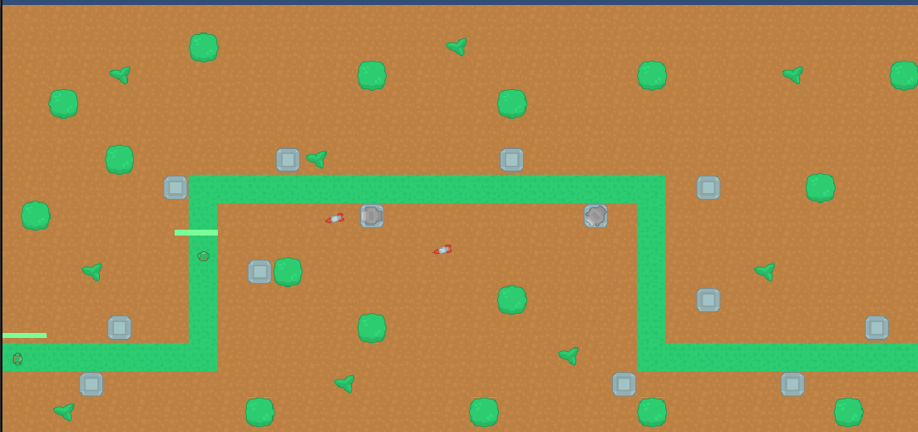
Рисунок 1 - Пример игры

